End-to-End Secure Tracking System of Precursor
Chemicals Using Blockchain with Anomaly Detection
Jyoti Yadav  Department of Computer Science  Engineering  Vishwakarma Institute of Technology  Pune, India jyoti.yadav@vit.edu | Sayali Prabhudas Wagh  Department of Computer Science  Engineering  Vishwakarma Institute of Technology  Pune, India sayali.wagh23@vit.edu | Sakshi Chandrakant Tupe  Department of Computer Science  Engineering  Vishwakarma Institute of Technology  Pune, India sakshi.tupe23@vit.edu
Arnav Satpal Sowale  Department of Computer Science  Engineering  Vishwakarma Institute of Technology  Pune, India arnav.sowale231@vit.edu | Pravin Sham Pinjarkar  Department of Computer Science  Engineering  Vishwakarma Institute of Technology  Pune, India  pravin.pinjarkar24@vit.edu | .

Abstract—The systems that are involved in the handling, processing, and distribution of chemicals have to be under tight control, verification, and compliance with all the laws that are applicable to the respective system so that it does not become a prey to the kind of misuse and manipulation that might take place. Conventional systems, which are based on the documentation approach, the traditional approach, tend to lay much emphasis on the handling of the system, which might cause complexities due to the kind of manual calculations that are involved. This paper proposes a web-based system, which has to be coined with a specific title like "Chemical Batch Tracking and Verification System."
In order to have the integrity of data and trust, there is an inclusion of blockchain technology, which is aimed at ensuring that there is a verification record, which is then stored in a way that it cannot be modified. Then there is an inclusion of statistical anomaly detection technologies, which are aimed at ensuring that there is an identification of abnormal patterns within the provided chemical data, as a way of verifying the provided data. Lastly, there is an inclusion of interaction facilities.
There are a number of ideas that have been proposed for further development. Some of the ideas include identity verification using a decentralized system and the application of AI for the development of decision support systems.

Keywords: Chemical Tracking, Blockchain Technology, Anomaly Detection, QR Codes,
MongoDB, Node.js, Document Verification, Supply Chain Security.

I. INTRODUCTION

To perform the process of production, distribution, and regulation of chemicals, transparency, traceability, and lawfulness are needed for a process to go forward. Traceability of chemicals will facilitate the management of hazardous substances and materials that require control. This is necessary to reduce the hazards or harms associated with misuse, theft, and/or degradation of substances and materials. To evaluate the importance of the traceability task for chemicals, the materials used can be utilized for such an assessment. Most chemicals used can be used for the creation of explosives and substances, there are a number of chemicals that require strict monitoring by regulatory bodies due to their potential for misuse. One of these chemicals is Sulphuric acid (H₂SO₄), which is a highly corrosive chemical used as a catalyst in the production of powerful explosives, nitroglycerin, and TNT, as well as controlled substances. Acetone (CH₃COCH₃), a highly combustible chemical, is a volatile compound widely used in the purification of illegal substances and in the production of peroxide-based explosives, TATP. Ammonium nitrate (NH₄NO₃), a chemical commonly used as a fertilizer, is also used in the production of a powerful explosive mixture, ANFO, which has been used in major attacks. Nitric acid (HNO₃), a highly corrosive chemical, is a powerful oxidizer used in the production of powerful military-grade explosives, PETN, RDX, and TNT, as well as in the production of toxic fumes.

There are also similar regulations and laws that are enforced by various bodies such as the Narcotics Control Bureau (NCB). Stringent rules and regulations help in the recording of certain substances at all stages of its lifecycle.
The complexity associated with the chain itself, as well as other areas that are checked when working with such energy sources, as may be noted in Figure 1 above, is a manifestation of the challenges encountered when ensuring traceability within this sector. As such, it poses some issues such as legal issues, environmental issues, as well as health/safety issues.

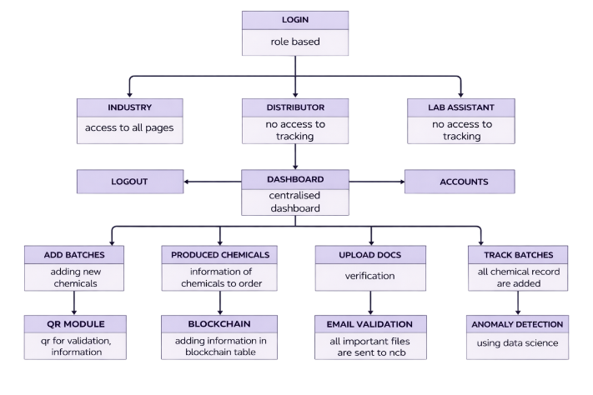
Fig.1 The Real-World Chemical Supply Chain Flow.

The above diagram shows the checkpoints and the movement of chemicals from the industry to the NCB and the end user. As can be understood, the process is very important but is currently based on a semi-digital system. The conventional systems are often prone to manipulation, loss of information, security problems, and access problems. The maintenance of the record is also a tedious task.

II. LITERATURE REVIEW

This paper focuses on the role played by blockchain in improving the level of transparency, traceability, and secure data exchange in the supply chain. The research, conducted using the PRISMA method, reviewed various studies on data security via blockchain technology. Despite the challenges that exist in the use of blockchain, which include the cost and complexity, the results indicate that it has the potential for use in the supply chain.[1]

The lack of visibility and traceability in the supply chain further proves the need for better information flow. Various research works have proposed better strategies to deal with the above problems, and all of them agree on the potential of blockchain technology in enhancing trust, transparency, traceability, and sustainability in supply chain management.2]

In this paper, challenges related to complex supply chains are discussed, and the need for resilience is highlighted. The paper reviews various studies on supply chain risk management published from 2000 to 2023. Based on this review, six major themes are identified, and recommendations are provided for future research. The study provides a clear roadmap for future research on supply chain resilience.[3]

This paper will discuss how technological advancements have impacted supply chain management, with a focus on blockchain as a key emerging technology. Although blockchain technology has been found useful in finance, this study will explore its integration with ERP systems in order to improve supply chain management. The analysis of literature will show potential benefits and areas of application of blockchain in supply chain management.[4]

The purpose of this paper is to assess the usage of blockchain technology in the supply chains of Algeria, with a focus on its significance to local and global economies. In addition, the benefits, limitations, and challenges of blockchain technology, as well as possible solutions, are addressed. Furthermore, a case study of its usage in the pharmaceutical industry is included.[5]

III. METHODOLOGY
.
The proposed system will be a lightweight, serverless, and efficient web application for the management of chemical batch tracking, based on the concepts of accessibility, usability, automation, and modularity. It will be implemented with simple web technologies in order to be cost-efficient and portable, and it will offload processing and management of data to the browsers of the users, hence avoiding the complexity of servers.

3.1 System Architecture: The Serverless Model
Regarding the above problem, the basic underlying concept would involve serverless architecture. In this regard, serverless architecture will ensure that there is maximum accessibility of the application, where all the functionality of the application will run inside the user’s own browser using static HTML, CSS, and JavaScript files.

Client-Side Execution: The browser is being used as a full application platform. It is used for the implementation of User Interfaces, validation checks, and application logic such as ID generation.

Local Data Persistence: Instead of using interaction with the database, all structured data, such as batch records, location histories, and simulations for user account information, are stored in the browser by utilizing the Local Storage API. It would permit persistent data, which remains stored even when the user closes the application.

Deployment Simplicity: The system can be deployed immediately by opening just the main HTML file on any machine. Secondly, this system can be deployed across the world on any static hosting site without any cost being paid for hosting and database services.
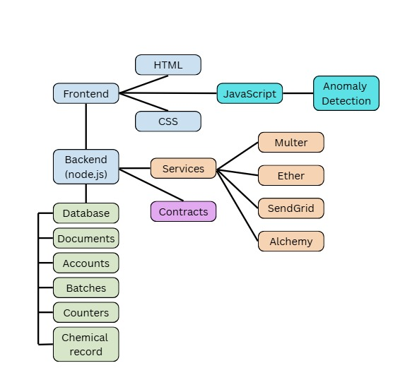

Fig.2 System Architecture of the Chemical Tracking

3.2 User Workflow and Process Flow This method follows a simple process to digitally implement the traditional process of dealing with chemicals. This helps in limiting the possibility of error caused by users. The flow in the system links each physical container to its corresponding digitized copy from the beginning.
Following are the complete lifecycle steps of a batch in this system:

- Authentication: The user logs in to the dashboard, which is represented by Local Storage for single-user scenarios.
- Data Entry: The user accesses the "Add Batch" section and enters information needed, such as chemical name, quantity, and manufacturer.
- Automation: The system will check data and create a unique Batch ID and Approval Number automatically.
- Label Generation: The system generates a printable QR Code with a unique Batch ID.
- Physical Labelling: The user will print out the physical QR Code label and place it on the container.
- Tracking Update: In case the batch has been moving, the user will use a QR code to access information regarding the batch, its identification, and update its location through the use of the State-City Mapping function.
- Audit/Query: The auditor/regulator can utilize this feature by scanning the physical QR code or searching the batch ID and then gaining access to the entire tamper-proof history via the client.

3.3 Core Functional Modules
The system is highly modular in nature. This feature guarantees the proper execution of complex operations by individual modules of the system. This makes it easier to add backend system integration in the future.

1. Batch Management Module
This module deals with the creation, updating, retrieval, and deletion of chemical batch records. It provides for the structured entry of data through the use of validation fields and allows administrators to search and filter batches according to parameters such as the name of the chemical and the date of manufacture. Once the data has been successfully validated, the system then goes on to the automated generation of ID and QR codes.
2 .ID and QR Code Automation Module
This module does away with the possibility of human error in numbering by automatically creating a unique Batch ID and approval number through the use of client-side algorithms after a successful submission of the batch. The ID is then instantly converted into a scannable QR code through the use of a JavaScript library.
3. Location Tracking Module

This module provides end-to-end traceability by recording each movement of the batch and status change with a timestamp and corresponding user ID. A standardized state-city selection mechanism reduces the chances of errors in input and ensures consistency in geographical information. The movement log created ensures an auditable trail of custody from the time of production to final distribution.

3.4 Technologies and Tools

Technology | Purpose in Project
HTML5 | Defines the structure and layout of the dashboard forms, tables, and views.
CSS3 | Manages the visual appearance, color scheme, and responsive layout of the application.
JavaScript | Handles all dynamic behaviour, data  persistence, ID generation, and module interaction.
Local Storage API | The serverless database provides simple, persistent key value storage within the browser.
QR Code Library | A client-side JavaScript library used to render scannable codes from batch IDs.
Table 1. Technologies and Tools Used

IV. RESULT AND DISCUSSION

The Web-Based Chemical Batch Tracking Dashboard was evaluated with regard to its main design objectives: automation, traceability, cost-effectiveness, and usability. The results revealed that the serverless architecture has been implemented correctly, creating a functional, efficient, and traceable chemical tracking system.

4.1 Automation and Data Integrity (QR Generation and Batch Management)
The main advantage of the Batch Management Module is that it removes the possibility of manual numbering errors. The client-side JavaScript applies a predictable algorithm to generate a distinct Batch Identification (ID) or Approval Number when submitted to the script.

The above problem can be solved in the system with the help of the effective automated process that can be seen in Figure 3. Moreover, in this particular case, the creation of a scannable asset tag right after performing validation would simplify the main goal of making sure that the system could perform physical 5 abelling at any given time.

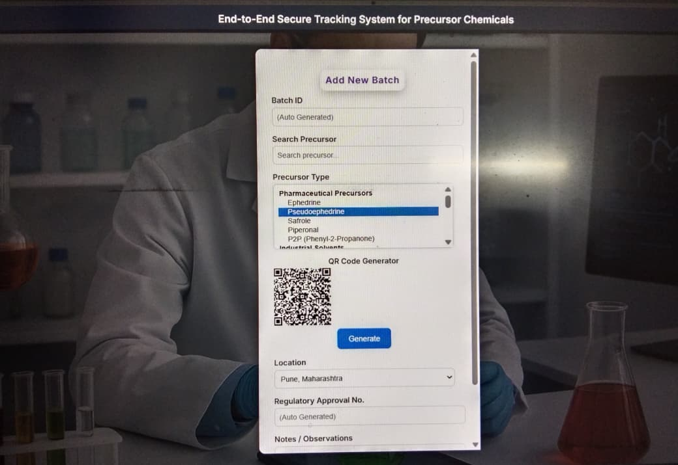
Fig 3. Batch Record Creation and Instant QR Code Generation.

This screenshot validates the existence of an automated pipeline. As is evident from the screenshot, there is a form to be filled with data, a unique Batch ID, and a printable QR code label.

4.2 Efficacy of Anomaly Detection and Risk

Visualization
It is very significant that the multi-factor Anomaly Detection Service was incorporated into the system, as explained above. As mentioned in the above explanation, the system shall employ the ensemble scoring mechanism, as explained in Section 3.2.C of the description. The system shall analyze data under the transactions section and look for major anomalies for the process. Analysis of ensemble scoring for batch transactions using the system is presented in Table 2.

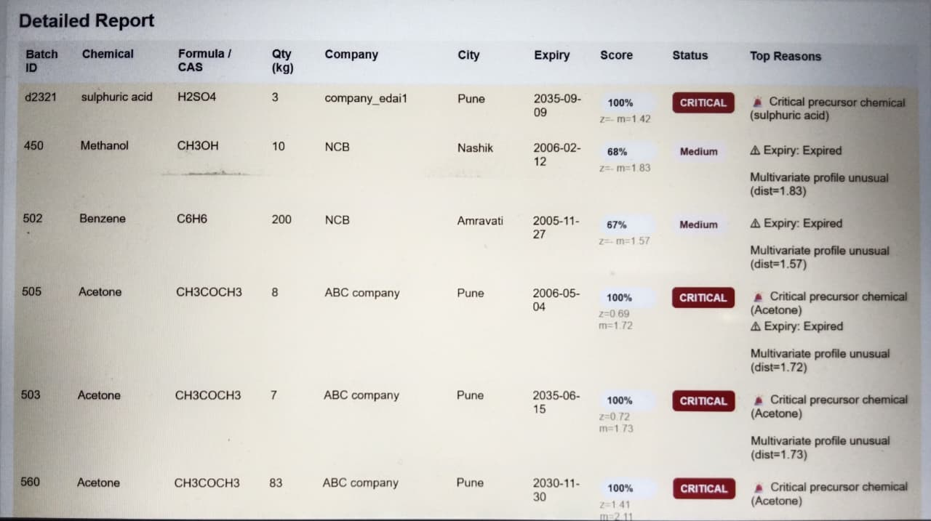
Fig 4. Anomaly Detection Dashboard and Risk Visualization.

This screenshot also illustrates the ability to evaluate or grade the submission and the prioritisation of risk, as indicated in the risk queue shown, which is prioritised on the part of the regulator, using the Ensemble Final Score.

Table 2 shows the results of the calculated anomaly scores between 0 and 1 on various main statistical indicators.
Batch ID | Chemical | Qty  (kg) | Status | Score | Primary Anomaly  Indicators
560 | Acetone | 83 | Critic al | 1.0 0 | Company  deviation; City deviation;  Multivariate deviation (dist=2.1 1)
509 | Butyl Lithium | 8 | Nor-mal | 0.16 | —
601 | Ethanol | 10  2 | Nor-mal | 0.1 6 | —
662 | Ammonium Nitrate | 10 | Criti-cal | 1.0 0 | High risk  Precursor  chemical
605 | Sulfuric Acid | 21  2 | Criti-cal | 1.0 0 | High risk  precursor  chemical
608 | Ephedrine | 20  0 | Nor-mal | 0.11 | —
609 | Ergotamine | 20  0 | Nor-mal | 0.11 | —
Table 2 Anomaly Detection Output Generated by the Proposed System.

A. Result Insights
- Critical Risk: The batches, which were listed as Critical Risk in eight (42.1%) instances, are influenced by a number of factors, namely, precursor category, expiration flags, multivariate distance ≥1.7, and so on.
- Multivariate Outliers: These results had a strong association with abnormal acquisition behaviors, e.g., Batch 560. This showed that it could identify minor deviations in standard patterns.
- Compliance Enforcement: The approvals given for high-risk chemicals that had expired were rated Critical in all cases, ensuring that appropriate compliance regulations were fulfilled.

4.3 Traceability and Auditable Chain of Custody (Batch Tracking)
The location tracking module in the system ensures that chronological information is provided. The provision of information in an auditable condition is enhanced through the standardization of geographical information provided in the State City Mapping feature. The Movement Log includes a list of unalterable data through the Local Storage API.
Figure 5 is an output screen showing results from searching for a specific batch record. All recorded movements and standardized location information, including the time stamp of the last update, are included in the output. We have again confirmed that the system supplies all traceability requirements for compliance and audit.

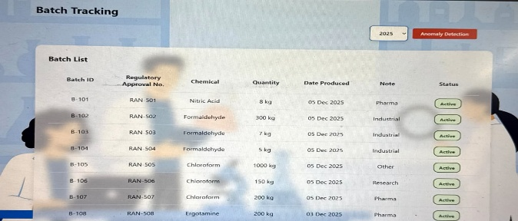
Fig 5. Traceability Validation: Auditable Chain of Custody and Location Tracking Interface.

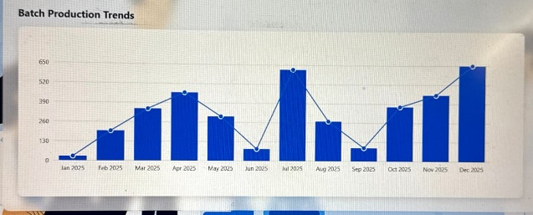
Fig 5.1 Precursor Chemicals Order Trends for Anomaly Detection

The screenshot above shows a historical log where the entire journey of a batch, including all updates, is shown to the auditor.

4.4 System Utility and Operational Efficacy (The Dashboard Interface)
The overall system architecture demonstrates its utility and cost-effectiveness. The purely client-side nature also eliminates any recurring costs and provides very fast page load and data retrieval times. The primary dashboard serves as a central location to manage the Local Storage repository.
Figure 6 shows the interface of the Centralized Dashboard. This interface offers auditors and administrators the necessary tools to efficiently run their system. The current examples of searching, filtering, and sorting are indicative of the batch records’ ability to efficiently be managed by this dashboard. This presents high utility without reliance on expensive backend server systems.

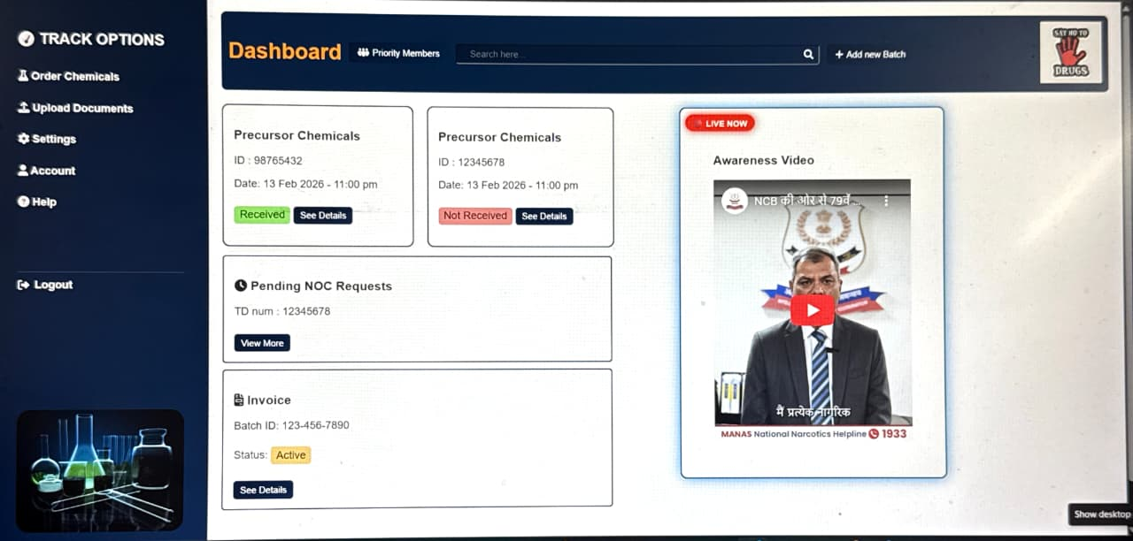

Fig 6. Centralized Dashboard

The screenshot above depicts the main search and result listing interface which administrators/auditors will utilize in order to efficiently filter and search all batch records stored in the local repository.

Figure 7 presents the document management interface This module allows distributors to upload and manage mandatory regulatory and safety documents such as SDS/MSDS, COA, TDS, disposal, compliance and transportation or import/export permits. The uploaded documents are organized and associated with their respective batch records, ensuring regulatory compliance, secure verification, and preventing the unauthorized flow of chemicals. The module also allows anomaly monitoring for document discrepancies.

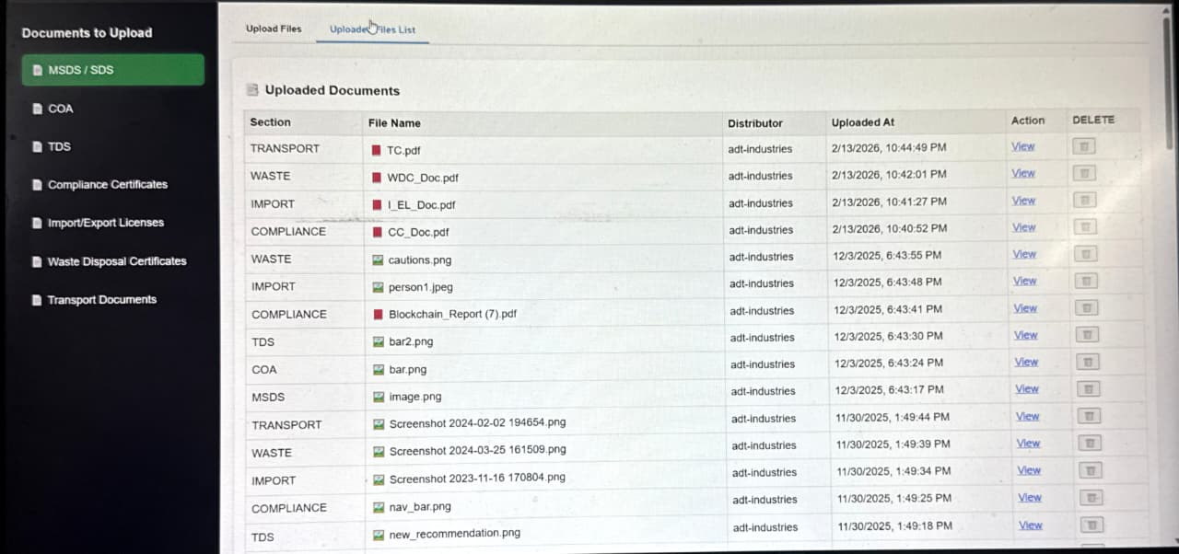

Fig 7. Secure Distributor Document Management Module
4.5 Chemical Records Dashboard Interface
Figure 8 shows a representation of a blockchain-based Chemical Records system with specific information on chemical batches, namely company names, formulas, CAS numbers, amounts, manufacturing and expiration dates, storage conditions, geographic information, as well as specific information related to blockchain transactions, namely block numbers and transaction hash values.

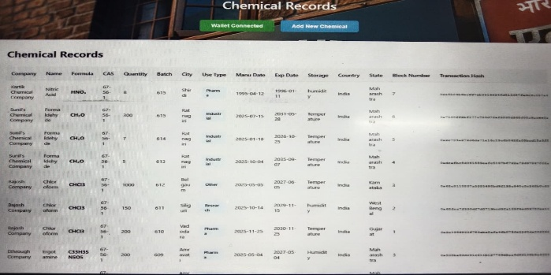

Fig 8. Blockchain-Enabled Chemical Records Management with Real-Time Traceability

4.6 System Participants and Their Roles
- Chemical Industry Owner (Manufacturer): Registers the chemical production facility on the blockchain network Initiates secure smart contracts for chemical transfer Ensures regulatory compliance and transparent record keeping Monitors supply chain movement in real time
- Distributor (Supply Chain Partner): Receives chemicals through blockchain-verified transactions Verifies receipts, logs usage, and check blockchain stored records. Uploads batch details including chemical type, quantity, purity, and timestamp verify chemical's documents uploaded by other chemical industry owner, Distributor
- Lab Assistant (Verification & Analysis Role): Arranges OTP-Based updates delivery records. Verifies chemical authenticity using blockchain records

V. CONCLUSION
The research paper presented the design and implementation of a web-based chemical batch tracking and management dashboard. The work proved that only basic front-end technologies (HTML, CSS, JavaScript) are sufficient to build an efficient, low-cost, and accessible technology for one critical regulatory domain.
This dashboard, by automating batch ID and QR code creation, digitizing location tracking, and centralizing the administration of documents, directly addresses the main weaknesses related to traditional methods of manual tracking-systematic error, inefficiency, and traceability.
The existing serverless architecture, having local storage, has its limitations regarding scalability and real-time collaboration. Still, it has proven its value as a proof of concept, which may serve as an essential tool in small-scale operations and/or for training purposes. Its value lies in its modularity, providing a good base for further enhancements by sophisticated backend and blockchain technologies. Another value of this work is in showing the usefulness of small-scale web solutions for the support and/or upgrading of key areas usually related to very costly software systems.

VI. REFERENCES

- S. Saberi, M. Kouhizadeh, J. Sarkis, and L. Shen, “Blockchain technology and its relationships to sustainable supply chain management,” International Journal of Production Research, vol. 57, no. 7, pp. 2117–2135, 2019.
- K. Francisco and D. Swanson, “The supply chain has no clothes: Technology adoption of blockchain for supply chain transparency,” Logistics, vol. 2, no. 1, pp. 1–13, 2018.
- M. Casino, T. Dasaklis, and C. Patsakis, “A systematic literature review of blockchain-based applications: Current status, classification and open issues,” Telecommunications Systems, vol. 67, pp. 353–371, 2018.
- H. Treiblmaier, “The impact of the blockchain on the supply chain: A theory-based research framework and a call for action,” Supply Chain Management: An International Journal, vol. 23, no. 6, pp. 545–559, 2018.
- Y. Tian, “An agri-food supply chain traceability system for China based on RFID and blockchain technology,” IEEE International Conference on Service Systems and Service Management, 2016.
- Reyna et al., “On blockchain and its integration with IoT: Challenges and opportunities,” Future Generation Computer Systems, vol. 88, pp. 173–190, 2018.
- Z. Zheng, S. Xie, H. Dai, X. Chen, and H. Wang, “Blockchain challenges and opportunities: A survey,” International Journal of Web and Grid Services, vol. 14, no. 4, pp. 352–375, 2018.
- M. Kamble, A. Gunasekaran, and S. Sharma, “Modeling the blockchain enabled traceability in agriculture supply chain,” International Journal of Information Management, vol. 52, 2020.
- J. Lin, Z. Shen, A. Zhang, and Y. Chai, “Blockchain and IoT based food traceability for smart agriculture,” Proceedings of the 3rd International Conference on Crowd Science and Engineering, 2018.
- C. Perera et al., “Anomaly detection in IoT-based supply chains using machine learning techniques,” IEEE Access, vol. 7, pp. 183201–183216, 2019.
- S. Kumar and R. P. Singh, “Role of QR codes in smart supply chain management systems,” International Journal of Logistics Systems and Management, vol. 34, no. 2, pp. 233–248, 2019.
- P. Kshetri, “Blockchain’s roles in strengthening cybersecurity and protecting privacy,” Telecommunications Policy, vol. 41, no. 10, pp. 1027–1038, 2017.
- X. Xu et al., “A taxonomy of blockchain-based systems for architecture design,” IEEE International Conference on Software Architecture, 2017.

